TENTATIVE MEETING DATES
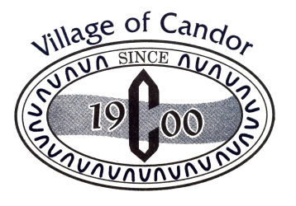
March 28
Budget Meeting Cancelled
~ ~ ~ ~ ~ ~ ~ ~ ~ ~
April 2
Board Meeting Cancelled
~ ~ ~ ~ ~ ~ ~ ~ ~ ~
April 23
Board Meeting @ 6:30 pm
With Public Hearing
for 2020-2021 Budget
At the Village Hall ~ 138 Main Street
~ ~ ~ ~ ~ ~ ~ ~ ~ ~
April 28
Village Elections
~ ~ ~ ~ ~ ~ ~ ~ ~ ~

